**First Version**

The article tells us that among developed nations, the US is the most homicidal country due to the easy access of many Americans have to firearms. The maps, plots and charts show the rate and nature of that violence, why it happens, and why it is such a tough problem to fix. I have tried to redesign some of the graphs : Graph 1, Graph 3 and Graph 5 to get a better version of the representation in the article.

### Supporting arguments in Graph 1:

### The United States has 90 guns per 100 people, the [highest ownership rate in the world](http://papers.ssrn.com/sol3/papers.cfm?abstract_id=1090441), while countries like Mexico has just 15, among the 59 countries for which the graph is made using a dataset. The federal government, with the support of the National Rifle Association, has no answer to the question: Does gun control work? The First graph studies the issue related to it. America has six times as many firearm homicides as Canada, and nearly 16 times as many as Germany. Reasons could be more permissive gun policies lead to more gun deaths, while more restrictive policies lead to fewer gun deaths.

### New vs Original graph:

### D:\Spring_Quarter3\68283 MS Information Systems 2629DashbdsScorecrdsand Visual\Individual project\Submissions_Indiv_Proj\Graph1.png

### Plot 1 shows that America has a very high rate of firearm homicides as Canada, and to be precise around 16 times as of Germany. But there is a lack of basic clarity of the graph. I think if it was a bar graph so content could show the comparison more elaborately, it would have been better. I would want to comment on the dataset as well. The people icon that was shown in the initial graph was not that meaningful and was adding to the size and length of the graph. So, I thought if removed, the graph would be able to cover more information.

### I tried to redesign and try to see how deceptive the graph was and how it has changed after modification. The python notebook gives a clear picture of the new modified version.

### The steps for data wrangling and steps to reach to the point is shown in the Jupyter file.

### Plot 2 (Article Graph 3) shows that there have been more than 1,600 mass shootings since Sandy Hook incident saying that there has been an increase in mass shooting cases because people in USA are allowed to carry guns and they misuse it. I think the heatmap could have a legend. The original graph does not contain exact numbers. Also, color legend is missing so I can even interpret it in the other way which would totally change the meaning of the graph.

### The modified graph has the exact number of mass shootings in different states. To make it look even better, factor-plots can also be considered (Added in Jupyter file). I think it can be modified to even look better because the graph shows the high value for Nevada and that is so huge that it makes the look and outcome of the graph somewhat less intuitive. It can be a future effort to modify and correct the issue which the new redesigned graph has in it.

### D:\Spring_Quarter3\68283 MS Information Systems 2629DashbdsScorecrdsand Visual\Individual project\g2.png

**Plot 3 (Article Plot 5):**

It represented the data in the form of a line graph and maybe the variables are regressed and shown state wise firearms incidents and possession details. I thought that it was deceptive because the % changes were not intuitive until and unless we see the dataset. I tried to make a boxplot and a small heatmap to show the distribution of firearm suicides/deaths in the country. Heatmap gives a hover image and is quite intuitive. Also, bar plot clearly shows the numbers and along with that compares it with other states simultaneously so it adds to the feel and information delivery of the graph.

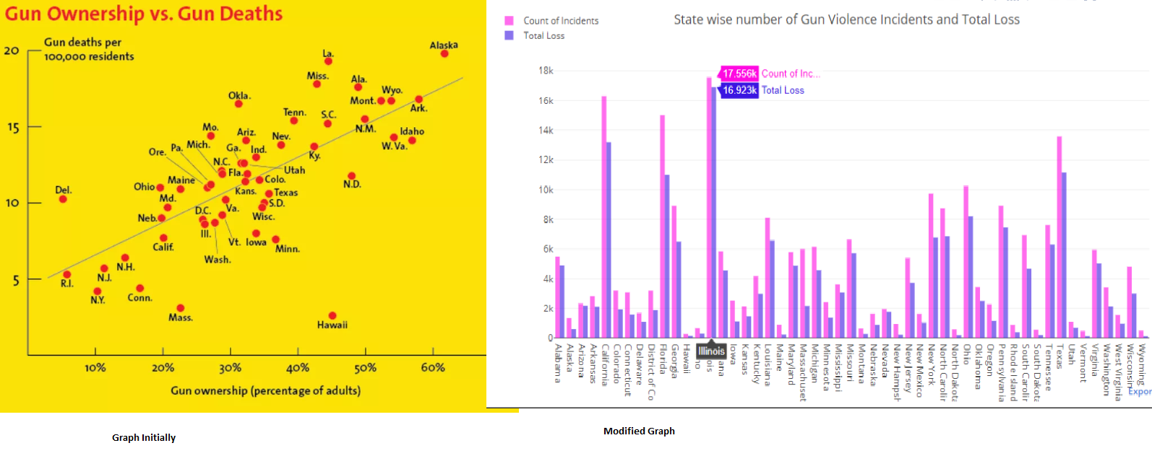

**Making-of:**

In brief I would want to highlight the steps that I took to achieve the redesigned product.

Step1: I read carefully about the graph in the article to reach the source of each of the graphs.

I found [Simon Rogers for the Guardian](http://www.theguardian.com/news/datablog/2012/jul/22/gun-homicides-ownership-world-list#data), [Harvard School of Public Health’s Injury Control Research Center](http://www.hsph.harvard.edu/hicrc/firearms-research/guns-and-death/) are the main important source for the data. Again, I also noticed that it was for developed countries so I researched again to find the list of developed countries and I found a reference to the Human Development Index, HDI official site. From there, I could find the list of countries I would base my filtering upon.

Then, I selected those countries and USA to see the claim that graph 1 made. I found it correct and intuitive.

For Graph 2 and Graph 3:

Step1: I searched the source from the article, and then downloaded the dataset.

Step2: I needed to use 2 tables for graph 2 so I tried to combine them. (Details in the attached Jupyter file).

Step3: I wanted to develop a bubble graph for my third plot which I will try and work on in the Revised Version phase.

Step4: Graph 2 requires certain normalization which I think I can rework on.

Step5: I found a same dataset with more row for the USA deaths and firearms possession. So, I used that to redesign graph 3.

**Future scope for enhancements:**

I tried to access the source data files and obtain dataset from it. I found that the sources mentioned an elaborative description of the case and also in some cases contradicted the finding in the graph. Also, as I mentioned above the graphs can be further improved with addition of more variables or new data to it. I want to take up some other graphs as well and come up with interesting findings about them.

Also, implementation of tableau can even help get more understanding and clear picture using the datasets which I managed to find out from the sources in the article.